SOLID Principle
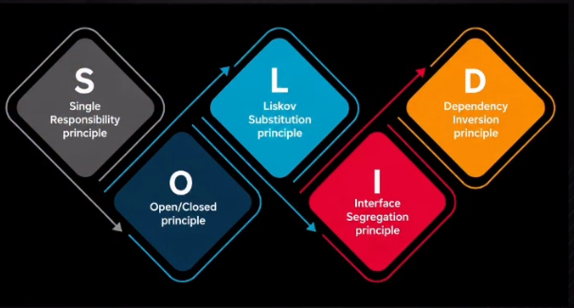

Single Responsibility Principle
A class should have one, and only one, reason to change. In other words, each class should focus on a single responsibility or job.
Example: An Employee class that handles too many responsibilities can become a “monster class.” For instance, if it calculates salary, manages employee details, and applies tax rules, then a change in the tax regime would require updating the salary-related logic inside the same class.

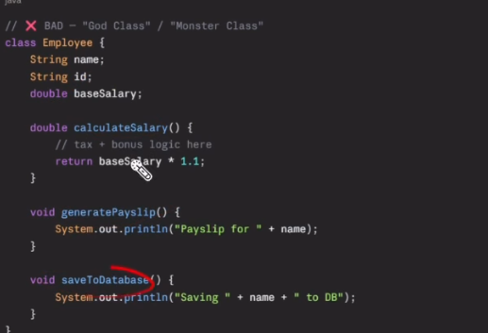

Solution: Break the large class into smaller, focused classes. This keeps each responsibility separate, makes the code easier to maintain, and reduces the risk that one change will affect unrelated functionality.
Result: The employee-related code becomes cleaner, safer to modify, and easier to understand.
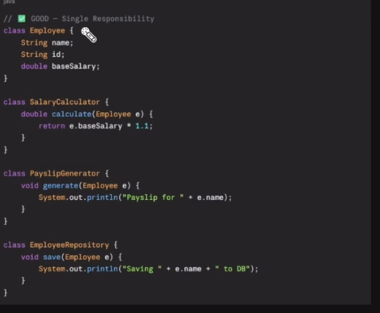

Open-Closed Principle
The Open-Closed Principle states that a class should be open for extension but closed for modification. This means new functionality should be added by extending existing behavior, not by changing code that is already tested and working.

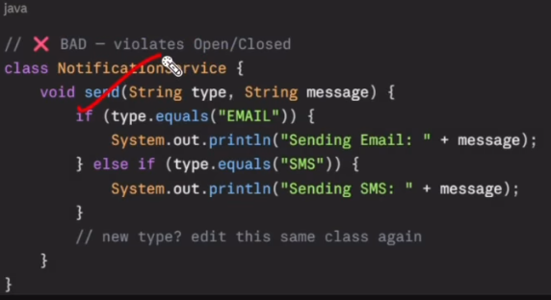
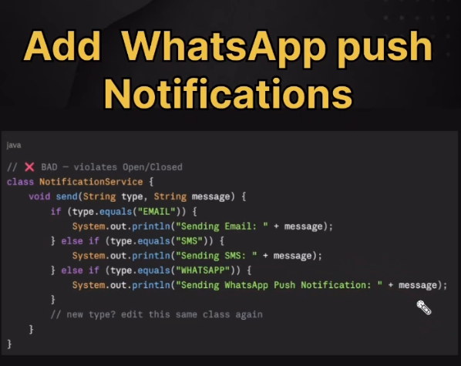Example: Suppose an application already supports email and SMS notifications. If we need to add WhatsApp or push notifications, we should avoid adding more if-else conditions to the existing, tested code. Changing that code can introduce bugs and make the system harder to maintain.
Solution: Use polymorphism and define a common notification interface. Each notification type, such as email, SMS, WhatsApp, or push notification, can have its own separate class that implements the interface. To add a new notification type, create a new class instead of modifying the existing code.
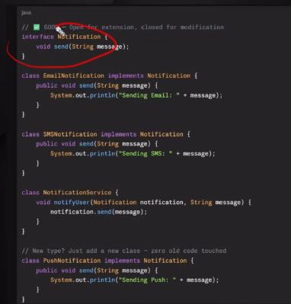

Dependency Injection
Dependency Injection (DI) is a design pattern in which an object receives the dependencies it needs from an external source instead of creating them directly. This makes the code easier to test, maintain, and change.
Scenario: Suppose an EmployeeController needs an EmployeeService to perform employee-related operations.

Without Dependency Injection
public class EmployeeController
{
EmployeeService service = new EmployeeService();
}
In this version, the controller creates the EmployeeService itself using new. This tightly couples the controller to the service implementation.

With Dependency Injection
public class EmployeeController
{
private readonly EmployeeService _service;
public EmployeeController(EmployeeService service)
{
_service = service;
}
}
In this version, the controller does not create the service object. Instead, ASP.NET Core provides, or injects, the EmployeeService automatically through the constructor.

UI Building
Use the following Angular CLI commands to create the student management UI project and generate the required components and services.

Create the Angular Project
ng new student-management-ui
cd student-management-ui

Generate Components
ng generate component components/classes

ng generate component components/students

Generate Services
ng generate service services/class
ng generate service services/student

Define the Class Model
The Class model defines the structure of a class record in the Angular application. It helps ensure that every class object follows the same format when data is displayed, created, or passed between components and services.
- classId: Stores the unique identifier for the class.
- className: Stores the name of the class, such as Grade 10 or Computer Science.

export interface Class {
classId: string;
className: string;
}

Define the Student Model
The Student model defines the structure of a student record. It makes the student data consistent across the application and helps the components and services work with strongly typed data.
- studentId: Stores the unique identifier for the student.
- firstName: Stores the student’s first name.
- lastName: Stores the student’s last name.
- email: Stores the student’s email address.
- classId: Links the student to a specific class.
export interface Student {
studentId: string;
firstName: string;
lastName: string;
email: string;
classId: string;
}

Define the Class Service
The ClassService is responsible for communicating with the backend API for class-related operations. It uses Angular’s HttpClient to retrieve, create, update, and delete class records.

Imports and Service Setup
import { HttpClient } from '@angular/common/http';
import { Injectable } from '@angular/core';
import { Class } from '../../models/class.model';
@Injectable({
providedIn: 'root'
})

Service Class and API URL
export class ClassService {
private apiUrl = 'https://localhost:7094/api/classes';
constructor(private http: HttpClient) { }

Read Classes
getClasses() {
return this.http.get<Class[]>(this.apiUrl);
}

Create a Class
addClass(classData: { className: string }) {
return this.http.post<Class>(this.apiUrl, classData);
}

Update a Class
updateClass(classId: string, classData: { className: string }) {
const url = `${this.apiUrl}/${classId}`;
return this.http.put<Class>(url, classData);
}

Delete a Class
deleteClass(classId: string) {
const url = `${this.apiUrl}/${classId}`;
return this.http.delete(url);
}
}

Define the Student Service
The StudentService handles communication between the Angular application and the backend student API. It uses Angular’s HttpClient to retrieve, create, update, and delete student records.

Imports and Service Setup
import { HttpClient } from '@angular/common/http';
import { Injectable } from '@angular/core';
import { Student } from '../../models/student.model';

Service Class and API URL
@Injectable({
providedIn: 'root'
})
export class StudentService {
private apiUrl = 'https://localhost:7094/api/students';
constructor(private http: HttpClient) { }

Read Students
getStudents() {
return this.http.get<Student[]>(this.apiUrl);
}

Create a Student
addStudent(studentData: Student) {
return this.http.post<Student>(this.apiUrl, studentData);
}

Update a Student
updateStudent(studentId: string, studentData: Student) {
const url = `${this.apiUrl}/${studentId}`;
return this.http.put<Student>(url, studentData);
}

Delete a Student
deleteStudent(studentId: string) {
const url = `${this.apiUrl}/${studentId}`;
return this.http.delete(url);
}
}
Summary: This service keeps all student-related API calls in one place, making the components cleaner and easier to maintain.

Configure Application Routes
The route configuration defines how users navigate between the main pages of the Angular application. In this setup, the default route opens the classes page, while separate routes are provided for the classes and students components.

Imports
import { Routes } from '@angular/router';
import { ClassesComponent } from './components/classes/classes.component';
import { StudentsComponent } from './components/students/students.component';

Route Definitions
export const routes: Routes = [
{ path: '', redirectTo: 'classes', pathMatch: 'full' },
{ path: 'classes', component: ClassesComponent },
{ path: 'students', component: StudentsComponent }
];

Build the Application Layout
The main layout provides a simple navigation menu for the Student Management System. Users can switch between the Classes and Students pages, while the routed component is displayed inside the router outlet.

Application Shell
<h1>Student Management System</h1>
<nav>
<ul>
<li routerLinkActive="active"><a routerLink="/classes">Classes</a></li>
<li routerLinkActive="active"><a routerLink="/students">Students</a></li>
</ul>
</nav>
<router-outlet></router-outlet>

